|  |  |
| --- | --- |
| Project Title | **Colorado Motor Vehicle Sales Data** |
| Tools | Visual Studio code / jupyter notebook |
| Domain | Finance Analyst |
| Project Difficulties level | Advance |

Dataset : Dataset is available in the given link. You can download it at your convenience.

[Click](https://drive.google.com/file/d/18nYH5vic8k7tCYLo0YiXlbVs4YTaA3Tr/view?usp=sharing) [here](https://drive.google.com/file/d/18nYH5vic8k7tCYLo0YiXlbVs4YTaA3Tr/view?usp=sharing) [to](https://drive.google.com/file/d/18nYH5vic8k7tCYLo0YiXlbVs4YTaA3Tr/view?usp=sharing) [download](https://drive.google.com/file/d/18nYH5vic8k7tCYLo0YiXlbVs4YTaA3Tr/view?usp=sharing) [data](https://drive.google.com/file/d/18nYH5vic8k7tCYLo0YiXlbVs4YTaA3Tr/view?usp=sharing) [set](https://drive.google.com/file/d/18nYH5vic8k7tCYLo0YiXlbVs4YTaA3Tr/view?usp=sharing)

**About Dataset Colorado Motor Vehicle Sales Data**

# Description

This dataset contains information on motor vehicle sales in various counties across Colorado, segmented by year and quarter. The data is useful for analyzing trends in vehicle sales, understanding the economic impact of automotive transactions, and making informed decisions in related business or policy planning.

# Columns

* **Year**: The calendar year in which the sales data was recorded.
* **Quarter**: The quarter of the year during which the sales were made. The quarters are divided as follows:

○ Q1: January to March

○ Q2: April to June

○ Q3: July to September

○ Q4: October to December

* **County**: The name of the county in Colorado where the sales were recorded.
* **Sales**: The total dollar amount of motor vehicle sales in the specified county and quarter.

# Use Cases

* **Economic Analysis**: Track the economic health and trends in the automotive market within Colorado.
* **Market Research**: Identify sales patterns and market demands in different counties.
* **Policy Making**: Inform decisions on automotive industry regulations and infrastructure planning.

# File Format

The dataset is available in CSV format, making it easy to import into various data analysis tools and software. The CSV file might be named colorado_motor_vehicle_sales.csv.

**Colorado Motor Vehicle Sales Data Analysis Project**

**Project Overview**

Objective: To analyze motor vehicle sales data in Colorado to identify trends, forecast future sales, and understand the factors influencing sales.

**Steps to Follow:**

1. **Define the Scope and Objective**:
   1. Identify the key metrics and objectives for the analysis (e.g., monthly sales trends, sales by vehicle type, forecast future sales).

○ Define the time frame for the analysis.

1. **Data Collection**:
   1. Gather motor vehicle sales data from reliable sources.

○ For this example, we'll assume a dataset named colorado_motor_vehicle_sales.csv.

1. **Data Preparation**:
   1. Clean the data to remove any inconsistencies or errors.

○ Prepare the data for analysis using tools like Pandas.

1. **Exploratory Data Analysis (EDA)**:
   1. Perform EDA to understand the data distribution and identify patterns.

○ Use visualization tools like Matplotlib and Seaborn to visualize the data.

1. **Statistical Analysis**:
   1. Perform statistical analysis to identify correlations and trends.

○ Use tools like Python (Pandas, Statsmodels) for this purpose. 6. **Predictive Modeling**:

○ Build predictive models to forecast future motor vehicle sales.

○ Use machine learning algorithms like Linear Regression, ARIMA, or SARIMA.

7. **Reporting**:

○ Summarize the findings in a comprehensive report.

○ Use visualizations to support the analysis and make the report more engaging.

**Example: You can get the basic idea how you can create a project from here**

**Step-by-Step Implementation**

1. **Data Collection**:

○ Assume you have a dataset named colorado_motor_vehicle_sales.csv with columns like Date, Vehicle_Type, Sales.

|  |
| --- |
| # Import necessary libraries import pandas as pd import numpy as np  import matplotlib.pyplot as plt import seaborn as sns  from statsmodels.tsa.seasonal import seasonal_decompose from statsmodels.tsa.arima.model import ARIMA from sklearn.metrics import mean_squared_error  # Load the dataset  data = pd.read_csv('colorado_motor_vehicle_sales.csv')  # Display the first few rows of the dataset print(data.head()) |

1. **Data Preparation**:

# Convert date column to datetime format

data['Date'] = pd.to_datetime(data['Date'])

# Check for missing values print(data.isnull().sum())

# Fill or drop missing values if necessary data.dropna(inplace=True)

# Aggregate sales by month data.set_index('Date', inplace=True) monthly_sales = data.resample('M').sum()

# Display the first few rows of the aggregated data print(monthly_sales.head())

1. **Exploratory Data Analysis (EDA)**:

|  |
| --- |
| # Plot total sales over time plt.figure(figsize=(12, 6))  plt.plot(monthly_sales.index, monthly_sales['Sales'], label='Total Sales') plt.title('Total Motor Vehicle Sales Over Time') plt.xlabel('Date') plt.ylabel('Sales') plt.legend() plt.show()  # Plot sales by vehicle type |
| vehicle_sales = data.groupby(['Date', 'Vehicle_Type']).sum().unstack() vehicle_sales.plot(kind='line', figsize=(12, 6)) plt.title('Motor Vehicle Sales by Type Over Time') plt.xlabel('Date') plt.ylabel('Sales')  plt.legend(title='Vehicle Type') plt.show() |

1. **Statistical Analysis**:

|  |
| --- |
| # Compute correlations between sales of different vehicle types correlation_matrix = vehicle_sales.corr()  # Plot the correlation matrix plt.figure(figsize=(8, 6))  sns.heatmap(correlation_matrix, annot=True, cmap='coolwarm') plt.title('Correlation Matrix') plt.show() |

1. **Predictive Modeling**:

# Perform seasonal decomposition on total sales

decomposition = seasonal_decompose(monthly_sales['Sales'], model='multiplicative', period=12)

|  |
| --- |
| decomposition.plot() plt.show()  # Fit an ARIMA model to the total sales data model = ARIMA(monthly_sales['Sales'], order=(5, 1, 0)) model_fit = model.fit() print(model_fit.summary())  # Make predictions  forecast = model_fit.forecast(steps=12)  # Plot the predictions plt.figure(figsize=(10, 6))  plt.plot(monthly_sales.index, monthly_sales['Sales'], label='Actual Sales')  plt.plot(pd.date_range(start=monthly_sales.index[-1], periods=12, freq='M'), forecast, label='Forecasted Sales', color='red') plt.title('Motor Vehicle Sales Forecast') plt.xlabel('Date') plt.ylabel('Sales') plt.legend() plt.show()  # Evaluate the model  mse = mean_squared_error(monthly_sales['Sales'][-12:], forecast) print(f'Mean Squared Error: {mse}') |

1. **Reporting:**

|  |
| --- |
| # Generate a summary report report = f"""  Colorado Motor Vehicle Sales Data Analysis Report  =================================================  1. Data Overview  ----------------   * Time Frame: {data.index.min()} to {data.index.max()} * Total Sales Data Points: {len(data)}   2. Exploratory Data Analysis  ----------------------------   * Total motor vehicle sales were plotted over time, showing general trends and seasonality. * Sales by vehicle type were plotted to compare different categories.   3. Statistical Analysis  -----------------------   * Seasonal decomposition of total sales showed clear seasonal patterns. * Correlation analysis showed relationships between sales of different vehicle types.   4. Predictive Modeling  ----------------------   * An ARIMA model was used to forecast motor vehicle sales for the next 12 months. * The model's Mean Squared Error (MSE) was: {mse:.2f}   5. Conclusions  --------------  - The analysis provided insights into the trends and seasonality of motor vehicle sales |

in Colorado.

- The predictive model can be used to forecast future sales, aiding in inventory management and sales strategies.

"""

print(report)

**Conclusion**

This project provides a comprehensive analysis of Colorado motor vehicle sales data, including data collection, preparation, exploratory analysis, statistical analysis, and predictive modeling. The resulting report summarizes key findings and insights, which can be useful for decision-making and strategic planning.

**Example: You can get the basic idea how you can create a project from here**

Sample code with output

|  |
| --- |
| *# This Python 3 environment comes with many helpful analytics libraries installed*  *# It is defined by the kaggle/python Docker image:*  *https://github.com/kaggle/docker-python*  *# For example, here's several helpful packages to load*  import numpy as np *# linear algebra* import pandas as pd *# data processing, CSV file I/O (e.g. pd.read_csv)*  *# Input data files are available in the read-only "../input/" directory*  *# For example, running this (by clicking run or pressing Shift+Enter) will list all files under the input directory*  import os for dirname, _, filenames **in** os.walk('/kaggle/input'):  for filename **in** filenames:  print(os.path.join(dirname, filename))  *# You can write up to 20GB to the current directory*  *(/kaggle/working/) that gets preserved as output when you create a version using "Save & Run All"* |

|  |  |  |  |  |  |  |  |  |  |  |
| --- | --- | --- | --- | --- | --- | --- | --- | --- | --- | --- |
| *# You can also write temporary files to /kaggle/temp/, but they won't be saved outside of the current session*  /kaggle/input/colorado-motor-vehicle-sales-data/colorado_motor_ vehicle_sales.csv  In [2]: df =  pd.read_csv('/kaggle/input/colorado-motor-vehicle-sales-data/co lorado_motor_vehicle_sales.csv')  In [3]: df.head()  Out[3]:   |  |  |  |  |  | | --- | --- | --- | --- | --- | |  | ye ar | quar  ter | county | sales | | 0 | 20 | 1 | Adams | 23160 | |

|  |  |  |  |  |  |  |  |  |  |  |  |  |  |  |  |  |  |  |  |  |  |  |  |  |  |
| --- | --- | --- | --- | --- | --- | --- | --- | --- | --- | --- | --- | --- | --- | --- | --- | --- | --- | --- | --- | --- | --- | --- | --- | --- | --- |
| |  |  |  |  |  | | --- | --- | --- | --- | --- | |  | 08 |  |  | 9000 | | 1 | 20  08 | 1 | Arapahoe | 55037  8000 | | 2 | 20  08 | 1 | Boulder/Bro omfield | 17677  1000 | | 3 | 20  08 | 1 | Denver | 20010  3000 | | 4 | 20  08 | 1 | Douglas | 93259  000 |   **EDA**  In [4]: import matplotlib.pyplot as plt import seaborn as sns  def perform_eda(df):  *# Print the shape of the DataFrame* print(f"Shape of the DataFrame: **{**df.shape**}\n**") |

|  |
| --- |
| *# Print the data types of the DataFrame* print(f"Data types:**\n{**df.dtypes**}\n**")  *# Check for missing values* print(f"Missing values:**\n{**df.isnull().sum()**}\n**")  *# Summary statistics* print(f"Summary statistics:**\n{**df.describe()**}\n**")  *# For each column* for column **in** df.columns:  *# Check if the column is numeric* if pd.api.types.is_numeric_dtype(df[column]):  *# Plot a histogram* plt.figure(figsize=(6, 4)) sns.histplot(data=df, x=column, kde=True) plt.title(f"Histogram of **{**column**}**") plt.show()  *# Check if the column is object type* elif df[column].dtype == 'object':  *# Plot a bar plot*  plt.figure(figsize=(6, 4)) sns.countplot(data=df, x=column) |

plt

.

title(

f"Bar

plot

of

**{**

column

**}**

"

)

plt

.

xticks(rotation

=

90

)

plt

.

show()

In

[5]:

perform_eda(df)

Shape

of

the

DataFrame:

(501

,

4)

Data

types:

year

int64

quarter

int64

county

object

sales

int64

dtype:

object

Missing

values:

year

0

quarter

0

county

0

sales

0

dtype:

int64

|  |
| --- |
| Summary statistics:  year quarter sales  count 501.000000 501.000000 5.010000e+02 mean 2011.570858 2.502994 1.760585e+08 std 2.266599 1.120041 1.642055e+08 min 2008.000000 1.000000 6.274000e+06 25% 2010.000000 2.000000 6.148200e+07  50% 2012.000000 3.000000 1.385820e+08 75% 2014.000000 4.000000 2.241580e+08 max 2015.000000 4.000000 9.169100e+08  /opt/conda/lib/python3.10/site-packages/seaborn/_oldcore.py:111 9: FutureWarning: use_inf_as_na option is deprecated and will be removed in a future version. Convert inf values to NaN before operating instead.  with pd.option_context('mode.use_inf_as_na', True): |

/opt/conda/lib/python3.10/site-packages/seaborn/_oldcore.py:111

9:

FutureWarning:

use_inf_as_na

option

is

deprecated

and

will

be

removed

in

a

future

version.

Convert

inf

values

to

NaN

before

operating

instead.

with

pd.option_context('mode.use_inf_as_na',

True):

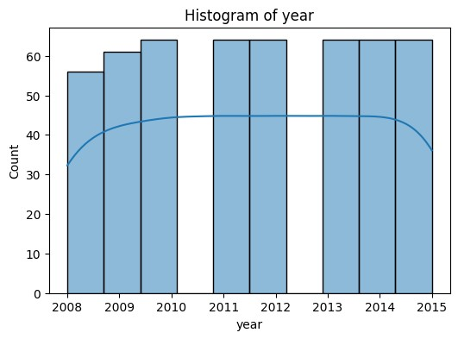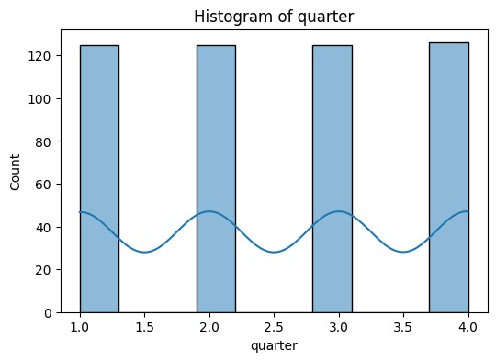

/opt/conda/lib/python3.10/site-packages/seaborn/_oldcore.py:111

9:

FutureWarning:

use_inf_as_na

option

is

deprecated

and

will

be

removed

in

a

future

version.

Convert

inf

values

to

NaN

before

operating

instead.

with

pd.option_context('mode.use_inf_as_na',

True):

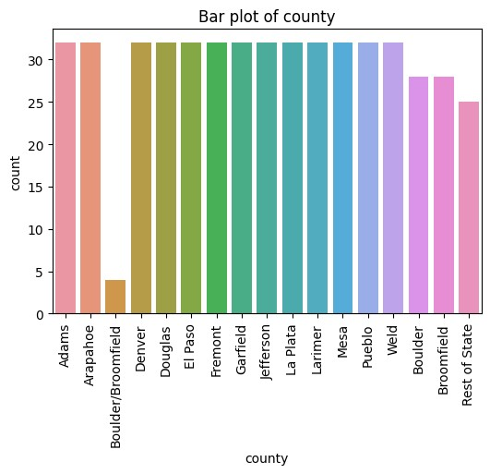

In

[6]:

*#*

*Create*

*a*

*new*

*column*

*that*

*represents*

*the*

*year*

*and*

*quarter*

df[

'period'

]

=

df[

'year'

]

.

astype(

str

)

+

'

Q'

+

df[

'quarter'

]

.

astype(

str

)

*#*

*Time*

*series*

*plot*

plt

.

figure(figsize

=

(

10

,

6

))

sns

.

lineplot(data

=

df,

x

=

'period'

,

y

=

'sales'

)

plt

.

title(

'Sales

Over

Time'

)

plt

.

xticks(rotation

=

90

)

plt

.

show()

*#*

*Box*

*plot*

*by*

*quarter*

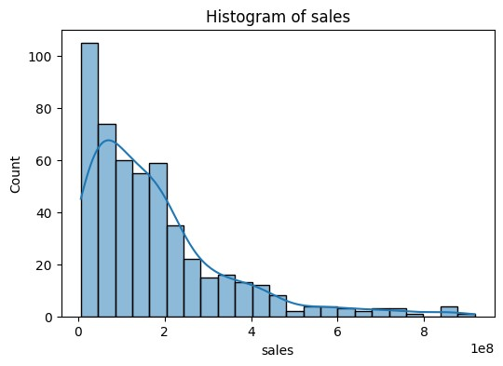

|  |
| --- |
| plt.figure(figsize=(10, 6)) sns.boxplot(data=df, x='quarter', y='sales') plt.title('Sales Distribution by Quarter') plt.show()  /opt/conda/lib/python3.10/site-packages/seaborn/_oldcore.py:111 9: FutureWarning: use_inf_as_na option is deprecated and will be removed in a future version. Convert inf values to NaN before operating instead. with pd.option_context('mode.use_inf_as_na', True):  /opt/conda/lib/python3.10/site-packages/seaborn/_oldcore.py:111 9: FutureWarning: use_inf_as_na option is deprecated and will be removed in a future version. Convert inf values to NaN before operating instead.  with pd.option_context('mode.use_inf_as_na', True): |

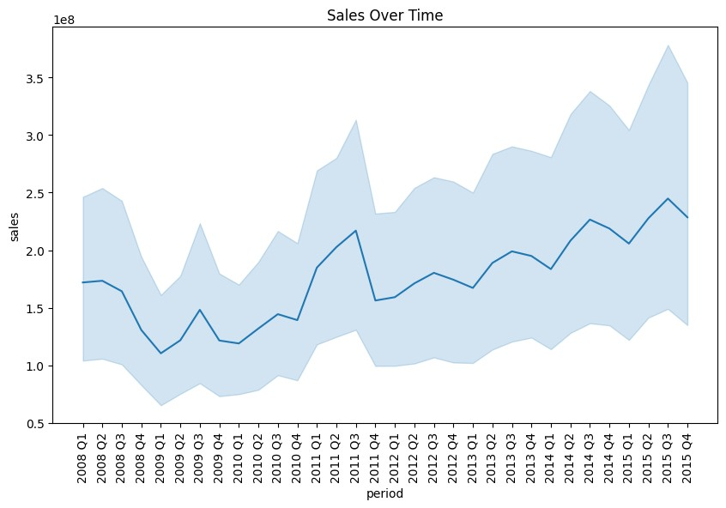

In

[7]:

import

ipywidgets

as

widgets

def

plot_sales_by_county(df,

year,

quarter):

*#*

*Filter*

*the*

*DataFrame*

*for*

*the*

*selected*

*year*

*and*

*quarter*

filtered_df

=

df[(df[

'year'

]

==

year)

&

(

df

[

'quarter'

]

==

quarter)]

*#*

*Group*

*the*

*data*

*by*

*county*

*and*

*sum*

*the*

*sales*

county_sales

=

filtered_df

.

groupby(

'county'

)[

'sales'

]

.

sum()

.

reset_index()

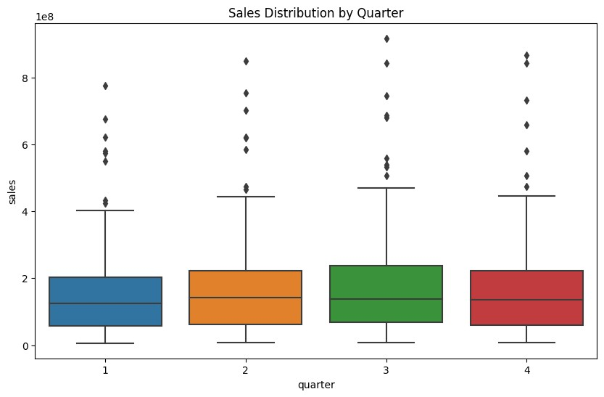

|  |
| --- |
| *# Sort the counties by sales* county_sales_sorted = county_sales.sort_values('sales',  ascending=False)  *# Create the bar plot* plt.figure(figsize=(12, 6)) sns.barplot(data=county_sales_sorted, x='county',  y='sales', palette='viridis') plt.title(f'Sales by County for **{**year**}** Q**{**quarter**}**') plt.xticks(rotation=90) plt.ylabel('Total Sales') plt.xlabel('County') plt.show()  *# Create widgets for year and quarter selection* year_widget = widgets.IntSlider(min=df['year'].min(), max=df['year'].max(), step=1, description='Year:') quarter_widget = widgets.IntSlider(min=df['quarter'].min(), max=df['quarter'].max(), step=1, description='Quarter:')  *# Use the interact function to create the interactive plot* widgets.interact(lambda year, quarter: plot_sales_by_county(df, year, quarter), year=year_widget, quarter=quarter_widget) |

Year:

2008

Quarter:

1

Out[7]:

<

function

__main__.<lambda>(year,

quarter)>

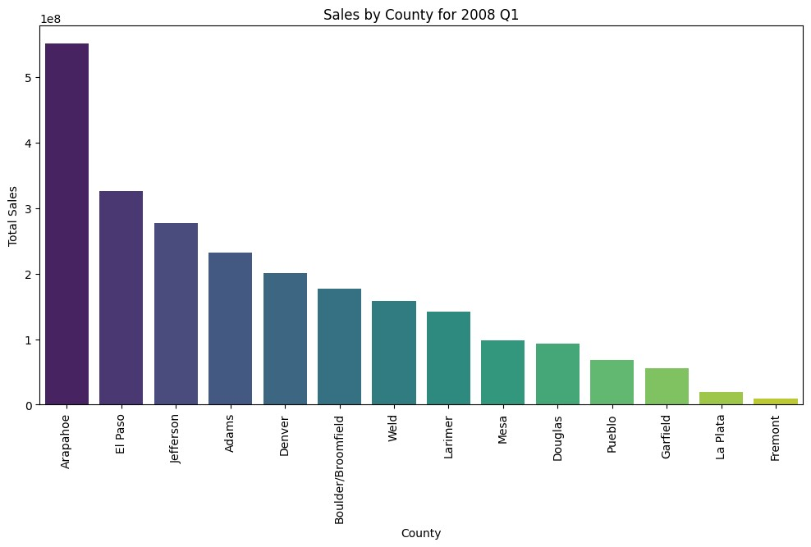

|  |
| --- |
| **This code creates two sliders that allow you to select the year and quarter. When you adjust these sliders, the function is called with the selected year and quarter, and it plots the sales for each county for that period.**  **Machine Learning**  **DISCLAIMER**: That this is just for demonstartion purpose.  **The number of features are not enough to make a trustworthy model.**  In [8]:  from sklearn.model_selection import train_test_split from sklearn.ensemble import RandomForestRegressor from sklearn.metrics import mean_squared_error  *# Convert 'county' column to categorical* df['county'] = df['county'].astype('category').cat.codes  *# Define features and target*  X = df[['year', 'quarter', 'county']] y = df['sales']  *# Split the data into training and testing sets*  X_train, X_test, y_train, y_test = train_test_split(X, y, test_size=0.2, random_state=42)  *# Initialize the model* model = RandomForestRegressor(n_estimators=100, |

|  |
| --- |
| random_state=42)  *# Fit the model* model.fit(X_train, y_train)  *# Make predictions* y_pred = model.predict(X_test)  *# Calculate RMSE* rmse = np.sqrt(mean_squared_error(y_test, y_pred)) print(f"RMSE: **{**rmse**}**")  RMSE: 20402876.97387048  In [9]:  from sklearn.model_selection import GridSearchCV  *# Define the parameter grid* param_grid = {  'n_estimators': [50, 100, 200],  'max_depth': [None, 10, 20, 30], |

|  |
| --- |
| 'min_samples_split': [2, 5, 10]  }  *# Initialize the model* model = RandomForestRegressor(random_state=42)  *# Initialize the grid search* grid_search = GridSearchCV(model, param_grid, cv=5, scoring='neg_root_mean_squared_error')  *# Fit the grid search* grid_search.fit(X_train, y_train)  *# Get the best parameters* best_params = grid_search.best_params_ print(f"Best parameters: **{**best_params**}**")  *# Fit the model with the best parameters* model = RandomForestRegressor(**best_params, random_state=42) model.fit(X_train, y_train)  *# Make predictions* y_pred = model.predict(X_test) |
| *# Calculate RMSE* rmse = np.sqrt(mean_squared_error(y_test, y_pred)) print(f"RMSE: **{**rmse**}**")  Best parameters: {'max_depth': None, 'min_samples_split': 2,  'n_estimators': 200}  RMSE: 19981856.206187755 |

[**Reference**](https://github.com/Subham2S/EDA-Car-Sales)[**link**](https://github.com/Subham2S/EDA-Car-Sales)